EASTERTON FLYING

OPERATIONS HANDBOOK

July 2025

OPERATIONS HANDBOOK

INDEX

Subject Page no

Introduction 4
- General
  - Chief Flying Instructor (CFI) 6
  - Private Gliders 6
  - Daily Inspections (DI) 6
  - Club Vehicles 7
  - Parachutes and Loggers 7
  - Dogs and other Livestock 7
- Ground Operations
  - Take-off Direction 7
  - Parking of Vehicles and Gliders 8
  - Towing of Gliders on the Ground 8
  - Vehicles and the “Runway” Area 9
  - Flying List 9
  - Daily Log 9
  - Visitors 9
  - Hangar Packing 10
  - Operations from 08 End 10
- Flying Conditions
  - Wind 16
  - Flying in Gusty Conditions 16
- Launching – General
  - Pre-flight Checks 16
  - Cross-wind Launch 16
  - “Stop” Signal 17
  - When Glider in later stage of Circuit 17
  - Preventing Over-run at start of Launch 17
  - Positive Control Checks Confirmation 17
  - Wing Tip Runner 17
- Launching – Aerotow
  - Prior to Launch 20
  - Launch Signals 21
  - Distractions On Tow 21
  - Release Procedure 21
  - Tow Pilots 21

- Launching – Winch
  - Prior to Launch 22
  - Weak Links 22
  - Cable Policy 22
  - Launch Policy 22
  - Launch Height 23
  - Cable Break Procedure (Not for Glider) Winch and Ground Crew 23
  - Take Off Procedure 23
  - Cross-wind Launch – Positioning of Winch 23
- Landing
  - Landing Area 24
  - Obstructions 25
- Flying Requirements 25
  - Prior to Solo and Immediately After 14 25
  - More Than 10 Solos 25
  - More Than 50 Solos but No Bronze Endorsement 25
  - Bronze Endorsement 26
  - Cross Country Endorsement 26
  - Silver and Higher 26
  - Check Flight Requirements 26
  - Silver in Absence of Instructor 26
  - Pilots Undertaking Mutual Flying 27
  - Instructors Not on the HGC Roster wishing to take a “PUI” 27
  - Aircraft Qualifications Required 27
  - Aircraft and Cross-country 28
- Miscellaneous
  - Daily Inspections 28
  - Winch Driving 28
  - Winch Cable Tow Out 29
  - Winch Cable Retrieve Equipment 30
  - Test Flights 30
  - Visitors from Other Gliding Sites 30
  - Flying of Club Gliders by Members of other Gliding Clubs 30
  - Flight Duration in Two Seat Glider 30
  - Grounds Maintenance 31
  - Approval for Purchase of Aircraft Types 31
  - Training 31
  - Conversion from K21 to Astir 31
  - Pilot Training Records 32
  - Requirements to Fly the DuoDiscus Solo 33
- Safety 33
Change Log 34

OPERATIONS HANDBOOK

INTRODUCTION

All who fly with the Highland Gliding Club or Fulmar Gliding Club at Easterton should read this booklet at least once per year and sign to confirm that they have done so.
The following does not negate the BGA rules and recommended practices that remain as stated in the current edition of "Laws and Rules".
Occasionally a compromise is made but, unless otherwise stated, these rules guide our actions here at Easterton. The Chief Flying Instructor (CFI) must approve any variations. What is set out in this booklet supplements the BGA "Laws and Rules" and is specific for this site.
Fulmar Gliding Club joined Highland Gliding Club at Easterton in 2000 on a permanent basis and now operates alongside. The launch equipment is shared between the two Clubs, as are the aircraft. In practice both Clubs operate as one.
Fulmar have their own Officer In Charge who oversees their operation, but overall responsibility lies with the Highland CFI as written down in the letter of agreement between the two Clubs.
The site here at Easterton consists of a strip of land extending in an approximately East/ West direction and is 360ft above sea level. There is a single grass runway approximately 1,000m long, varying between 35-100m wide and aligned 260º/080º. The runway is reinforced with “Perfo” plastic matting at the both ends, the reinforced area is 6m wide and 280m long at the east end and 6m wide and 70m long at the west end. The reinforced area is identified by white centre line stripes.
To the north of the site is the Mannochmore/Glenlossie Distillery complex with the town of Elgin further away. To the southwest are Glenlattarach Reservoir Dam and the River Lossie. Further south there is a large wind farm on the moor with the windmills extending to a height of 300ft above ground. This wind farm could be a distinct hazard when returning low level (less than 1400ft above site) from the Grantown direction as the windmill height is about 1300ft above the site. Another similar wind farm has been built further away, on Pauls Hill. This is also on high ground to the south of Easterton nearer Ballindalloch towards Grantown. Several other wind farms are situated not too far away from the site. To the south is a line of very high-tension pylons 500ft AAL (Above Airfield Level) that are within the circuit pattern. Care must be taken when flying in their vicinity. The ground to the south rises fairly rapidly to 1,000ft AAL about 1.5 miles from the site. To the east and south are situated Rothes and the main Elgin-Perth road (A941). The runway directions are “26” and “08”.

The hours of operations at Easterton are from 07.30 am until 9.00pm with last take off at 8pm. These times must be strictly adhered to.
Easterton is situated approximately 8 miles due south of Lossiemouth town and RAF station.
A Letter of Agreement (LoA) is in place which establishes procedures that will minimise the flight safety risk between aircraft operating from RAF Lossiemouth and gliders flying from Easterton. Pilots intending to fly from Easterton must be familiar with the contents of this LoA, a copy is available on the HGC Website, Members Area, General, General Downloads.
In order to maintain good relations and minimum conflict it is essential that on any day gliding is to take place, a procedure is followed involving contacting RAF Lossiemouth ATC by phone before starting and after ceasing operations at Easterton. See the Letter of Agreement.
The Club has an excellent website – www.highglide.co.uk. This contains a wealth of information pertaining to all aspects of the Club and has many excellent photos. It has links to other gliding Clubs, the British Gliding Association (BGA) and other relevant organisations.

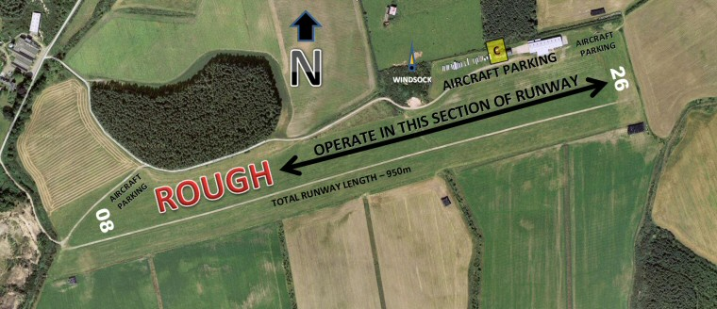

1.0 GENERAL

1.1 Chief Flying Instructor (CFI).
On each day the CFI is in overall charge of all gliding activities.
He/she has arranged that there will be a duty rota whereby designated Instructors will run operations each day. For gliding to take place at any time there should be an Instructor present at the site. Only in certain circumstances, as decided by the CFI, will flying take place when no Instructor is present. Mid-week flying is an example of such a circumstance. These circumstances will only apply to pilots possessing a Silver or higher qualification.
The CFI will take on the role of Airfield Authority with power of sanction over all pilots at Easterton. This authority will be delegated to Duty Instructors.

1.2 Private Gliders.
If a person wishes to fly a privately owned glider at Easterton the CFI should be consulted first as to the suitability of the aircraft for the site and/or the person(s) concerned.
Check flights will apply equally to a person flying their own glider as to when flying Club aircraft. Permission to keep their glider at Easterton, either in the hangar, or workshop, or in the trailer park, should be sought from the HGC Board. Private gliders shall all be adequately insured at least for third party risks and shall have a valid ARC if flown. The CFI or a designated deputy can ask for evidence of this at any time.

1.3 Daily Inspection (DI).
Each Club glider shall receive a DI by an authorised person before it is flown on any day, and the DI book should be endorsed accordingly.
Any Club glider newly rigged should receive a DI by an authorised person not involved in the rigging. It is recommended that private owners follow this practice.
Any faults found at the DI, however small, should be noted in the DI book and reported to the Duty Instructor and/an Inspector. In all cases an inspector must be made aware of the issue in a timely manner.
While a DI is taking place, the person carrying out the DI should not be approached or distracted by others except in exceptional circumstances or to assist with positive control checks.
Persons approved to carry out DIs on Club aircraft must pass an annual review and briefing on DI. The CFI or Engineering Officer will carry out these. The CFI and Engineering Officer will themselves be subject to the annual review and briefing. A list of persons approved to carry out DI on Club gliders will be maintained by the CFI.

1.4 Club Vehicles.
Only approved Club Members, or learners over 14 years old, under direct supervision of an approved person, should operate Club-owned vehicles. Club vehicles should be inspected each day before use for sufficient fuel, oil, water and correct tyre pressures. Any mechanical fault on Club vehicles should be reported to the Duty Instructor immediately.
Young and unlicenced members of the Club may be permitted to drive Club vehicles, provided they have received adequate training, are deemed competent and this has been recorded on their Ground Training Card. The Board may review this policy and change it from time to time.
NB - Passengers, especially young children, should not be carried on the tractor.

1.5 Parachutes and Batteries.
These should not be left in aircraft overnight. At the end of each day they should be removed and returned to their proper store.
Parachutes should NEVER be placed on the ground, however briefly.
Before use, Club parachutes should be inspected for serviceability and date of last packing. They should be repacked once every 12 months.

1.6 Dogs and other Livestock.
Dogs must be kept under control at all times. Dogs must be kept on a lead at all times while the site is active. Any Club member or visitor whose dog is a nuisance will be reminded of their obligation and if they do not comply they will be asked to remove their dog. They will be allowed to bring their dog in the future ONLY if they can show corrective training has been competed. These obligations apply to ALL people who bring animals on to the site.
NB – Dogs and other livestock are not allowed in the Clubhouse at any time.
Another aspect of responsible dog ownership is cleaning up after your dog. This is a legal
requirement in public places. The Club urges all dog owners to do likewise while at Easterton. Apart from being unpleasant there is a health issue if this is not done. Families with small children come to the Club. The area near the Clubhouse, near the launch points, car parking areas and trailer park are the important places to keep clean.

2.0 GROUND OPERATIONS

2.1 Take-off Direction.
This shall be decided by the Duty Instructor. It will normally be into wind.
2.2 Parking of Vehicles and Gliders.
Cars should be parked in the designated parking areas. As few cars as possible should be at the launch point and only to allow smooth running of launching and retrieving of aircraft. Such cars should not be parked in the close vicinity of the signal car. If cars park beside the signal car on a sunny day reflections from them may mislead the winch driver.
The bus should be parked close to the boundary fence and to one side of the tractor track so that its signalling lamp can be seen clearly by the winch driver.
When launching from the East end, gliders should be parked on the north side of the strip to the east of the grey hangar, in a position where they will not obstruct aircraft moving to or from the power hangars. They should only be taken to the launch area just prior to their launch. When launching from the west end, gliders should be parked near the west boundary in a position where they will not obstruct launching or landing of aircraft.
Powered aircraft (Tug, motor glider or visiting aircraft), should park in the north east corner as close to the boundary as possible at the east end and at the west end, close to the western edge of the wood out of the line of the runway.

2.3 Towing of Gliders on the Ground.
When towing a glider the rope used should be longer than half the wingspan of the biggest glider to be towed. The rope should be attached to the belly hook of the glider.
During towing care should be taken to prevent the controls moving about. This is especially important when towing down-wind. The safety harness can be used to limit stick movement.
The up-wind wing tip should be held and somebody should walk in front of the glider to prevent an over-run. If any sharp turns are to be made, tail-dragger gliders should have the tail lifted if not on a dolly. If towing along a sideways slope (as near west end on
north side), the down-slope wing tip should be held.
NB - When towing a glider from the hangar to the west end (when launching direction is to the east), before passing the windsock hill, care should be taken to ensure no aerotow launch is about to take place. If so, then the glider and car should stop there and wait for the launch to proceed. A radio call must be made to the launch point prior to moving further. The towing combination should then cross from the north side to the south and tow the glider close to the south side of the south runway where it will be visible from the launch point.
When retrieving a glider, the route taken back to the launch point or hangar/trailer should normally be along the north side of the site and as close to the boundary as is safe until the appointed glider parking area is reached, but see above for the exception. The tow car should remain aware of gliders joining the circuit so as not to obstruct them landing. When a glider is about to land towards the car/glider combination, the tow should be stopped.
2.4 Vehicles and the "Runway" Area.
Only retrieve vehicles are allowed on the runway and care must be taken to avoid driving in wet areas where damage could occur. Any damage must be repaired immediately.
Cars wishing to cross the field must go round near the boundaries avoiding the take-off
and landing areas. Occasionally this rule is waived for safety.
Any vehicle driving on the runway must carry an air-band radio tuned to the site frequency.
2.5 Flying List.
Trainees and those requiring an Instructor can book instructional slots via the website (highglide.co.uk). A similar system operates for those wanting a trial lesson. For other
members and visitors wishing to glide, an informal list may be compiled and kept near the log box that is usually at the launch point. During instructional slots the student has sole use of the two-seater and Instructor.
2.6 Daily Flying Log.
All members shall be responsible for ensuring that the Daily Flying Log is kept accurately.
The times for all take-offs and landings of all aircraft shall be entered in the Daily Log. It is usual that the person operating the light signals to the winch also looks after the Log. Any pilot landing out must, on return, ensure that all the necessary details are entered in the day’s log.
NB: The log is a legal document, it must be comprehensive and accurate. There is a separate document “Notes on Keeping the Log” that provides more detail than given here. All Club members should read this and comply with its contents. A copy is kept in the log box.

2.7 Visitors.
All Club members shall ensure that members of the public visiting the site are approached without delay, welcomed to the site and given every assistance to enjoy their visit safely.
Visitors shall be kept clear of the launching and landing areas and from parked aircraft unless accompanied by a Club member.
Visitors should be told to park their cars only in the designated places and should be escorted to the launching area as appropriate. They should be instructed to keep children under close supervision and never to go near the launching cables at any time, or to go alongside or in front of a glider awaiting a launch. Vehicles are parked on site at their owners’ risk. Note that your car insurance policy may not cover you while on an active airfield.
Visitors should always be made welcome as they could be our future members.
2.8 Hangar Packing
At the end of a flying day the Duty Instructor is responsible for seeing that all the equipment is safely put away.
It is easy for aircraft to be damaged during hangar packing and unpacking.
Aircraft must be moved slowly and with sufficient persons taking part to ensure that one aircraft does not touch another and that no part of the aircraft contacts an obstacle that would cause it damage. Normally hangar packing requires a minimum of 3 persons to ensure safe operations, for larger aircraft 4 or 5 persons may be required.
The person on the wing tip steers the glider into position and directs the others as required.
If at any point any person is not sure that the operation is taking place safety then they should shout STOP. All movement of the aircraft must cease until it is clear that the operation can continue without any damage being caused.
Reposition any moveable obstacles such as glider hangar trolleys, dust bins, chocks, etc out of the path of the aircraft and of those manoeuvring it.
Ensure that, when parked, there is sufficient space around the aircraft to ensure that any movement of control surfaces will not result in contact with an obstacle and that, should a tyre go flat, no damage will be caused by the resultant “sinking” of the aircraft.
Most gliders will require canopy covers to be fitted while in the hangar. Some gliders will also require wing covers, these must be fitted before the glider is parked. Covers will not normally be applied to wet aircraft.
The aerotow tug will always be the last aircraft to be placed in the hangar and it must be parked nearest the main hangar door.

2.9 Operations From West (08) End

The objective of these new ways of working for the 08 end is to eliminate the risk of injury or damage caused by contact with a fast moving aerotow rope. This will be achieved by providing a segregated tug landing run, free from incursion by cars, aircraft or persons. The tug landing run will occupy a section along the strip the width of which stretches from the north side of the Perfo to the edge of the winch tow out track.

AEROTOW ONLY
Gliders with pilots in the cockpit, ready to launch, will park on the 08 runway numbers with the wingspan parallel to the Perfo. Once the tug has landed the aircraft will be swung round to line up with the strip and the launch may commence.
Gliders in the immediate queue for launch will park temporarily immediately to the north of the 08 runway numbers, close to the boundary.
Gliders parked at the 08 end which are not in the launch queue will park in the north west corner of the strip, between the boundary and entrance road.
Cars parked at the 08 end will be positioned next to the entrance road immediately to the east of the glider parking area.
The bus, if in use, will park immediately to the south of the cars parked next to the entrance road.
An overflow car park area will be available next to the western boundary of the south strip.
An overflow glider parking area will be available immediately to the east of the overflow car parking area.
MIXED AEROTOW AND WINCH OPERATIONS
Glider winch launches will all take place from the south strip. Gliders which have landed and which intend to take a winch launch will tow back to the launch point along the south strip, provided that the ground is not too soft.
Up to 2 gliders at a time may be lined up ready to winch launch. They will be positioned one behind the other immediately to the south of the tow out track.
Gliders in the queue for winch launch will park in the south west corner of the strip, between the boundary and entrance road, immediately to the east of the car parking area.
Cars parked at the 08 end may be positioned next to the western boundary of the south strip or next to the entrance road immediately to the east of the aerotow queue glider parking area.
Gliders for aerotow, with pilots in the cockpit, ready to launch, will park on the 08 runway numbers with the wingspan parallel to the Perfo. Once the tug has landed the aircraft will be swung round to line up with the strip and the launch may commence.
Gliders in the immediate queue for aerotow launch will park temporarily immediately to the north of the 08 runway numbers, close to the boundary.
Gliders parked at the 08 end which are not in the immediate launch queue for aerotow will park in the north west corner of the strip, between the boundary and entrance road.
The bus will be positioned in line with the tow out track, close to the western boundary but leaving room for cars to pass behind it.
WINCH ONLY
Gliders ready to launch will be positioned one either side of the tow out track.
Gliders awaiting their turn to launch may be parked either at the western end of the south strip immediately to the east of the cars or in the north west corner of the strip, between the boundary and entrance road.
Cars parked at the 08 end may be positioned next to the western boundary of the south strip or near the western boundary between the 08 numbers and the tow out strip.
The bus will be positioned in line with the tow out track, close to the western boundary but leaving room for cars to pass behind it.

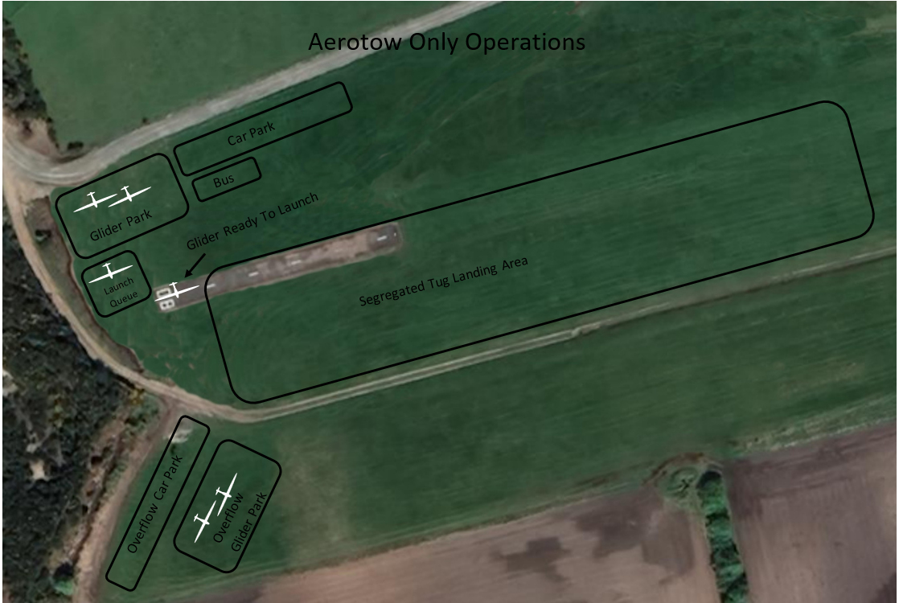
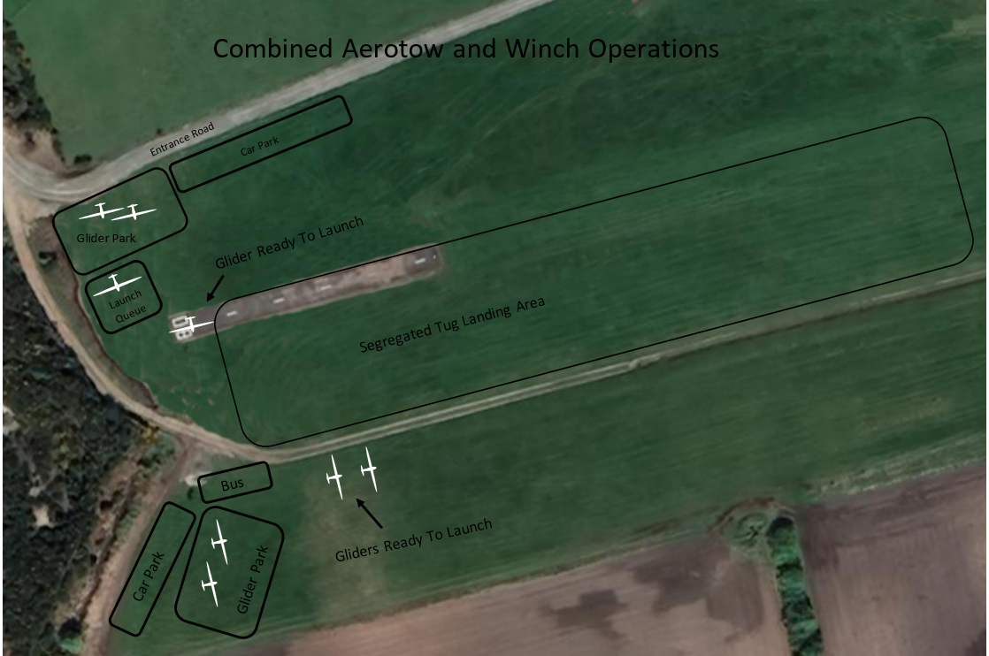
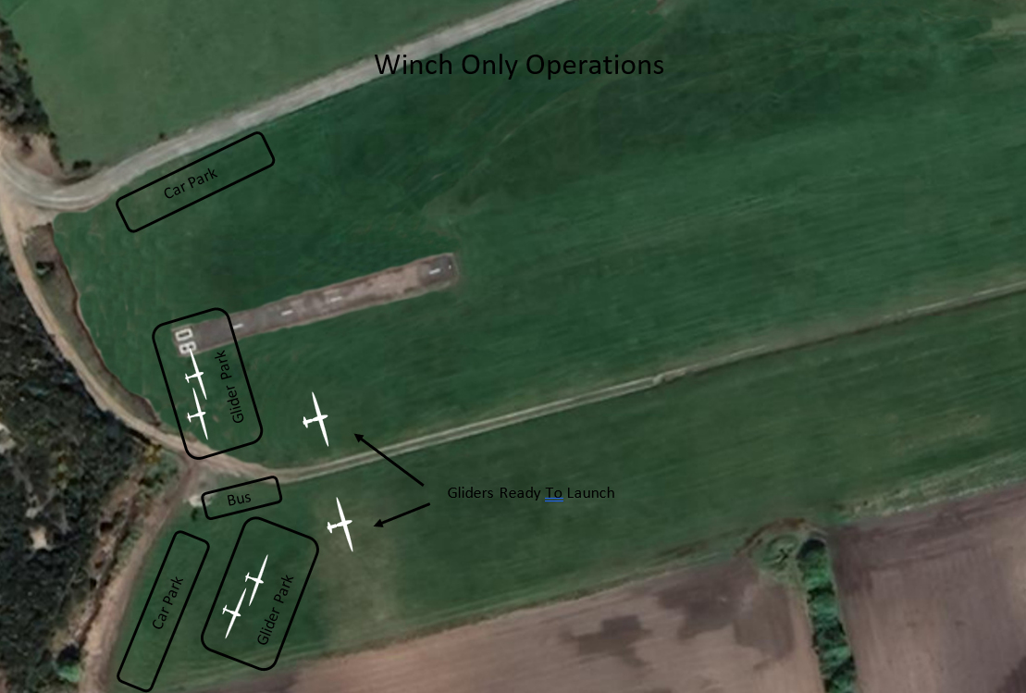

3 FLYING CONDITIONS

3.1 Wind.
Flying should not normally take place when the wind speed is greater than as follows:-
(a) Straight up and down strip (SW or NE) - 25kt
(b) 45 degree cross wind – 20 kt
(c) 90 degree cross wind - 10 to 15kt
If at the same time the conditions are gusty or turbulent, then flying should cease at much lower wind speed maxima. The Duty Instructor or CFI or deputy will decide which aircraft are safe to fly, depending on the weather conditions and experience of those flying them. The crosswind limitations of the tug in use may prevent launching in less windy conditions than shown above.
3.2 Flying in Gusty Conditions
In such conditions, especially in south or southeast winds, only suitably experienced pilots should fly as P1. Such people are usually Silver pilots or Instructors who are in current practice and are familiar with the site. The duty Instructor or CFI or deputy will advise in such conditions. All other pilots must consult one of these people before flying.

4 LAUNCHING - GENERAL
4.1 Pre-Flight Checks
Prior to entering the cockpit, ABCD checks shall be carried out. These checks comprise: Airframe, Ballast, Controls and Dolly.
Prior to take off CBSIFTBEC checks shall be carried out. These checks comprise: Controls, Ballast, Straps, Instruments, Flaps, Trim, Brakes, Eventualities, Canopy. For R1, at the canopy check, ensure that the canopy is flush with the fuselage and that the latching rod is through the fuselage fittings.
4.2 Cross-wind Launch.
When launching in strong crosswinds, the wing tip holder should hold the down-wind wing tip so as to reduce the risk of the glider swinging into wind on take-off. The wings should be kept level by the wing tip holder. If the glider does swing at the start of the ground run and/or a wing contacts the ground, then the pilot should release the cable immediately. If there is any delay in releasing in this situation it very quickly becomes almost impossible to release and a ground loop or cartwheel will follow, probably resulting in a serious accident. The launch should be abandoned if the wing is in danger of touching the ground in any wind direction.

4.3 “Stop” signal
If at any time ANY person sees ANYTHING that might conflict with the launch or compromise its safe outcome, for example - someone walking across the field half way down the strip, he/she should shout "STOP". This command should be repeated as soon as possible by radio. In the initial stages of a launch, if the pilot hears the command "Stop", he/she should immediately release the cable. Note – All types of launching should cease after a “STOP” signal has been given until it is deemed safe to resume operations.

4.4 When Gliders are in Later Stage of the Circuit
It may be safe to initiate an aerotow or powered aircraft launch if the airborne glider is in the first half of base-leg or earlier stage of its flight, provided the launch can start without delay. If it is nearer the approach phase than this, powered aircraft should be prevented from lining up on the runway and the glider pilot waiting to take off should wait until it is certain that the landing glider will not conflict with his/her launch. If launching by winch, it is advisable to delay a launch if the glider is downwind abeam the landing area; its subsequent approach could otherwise be compromised if the launching glider has a cable break.
If there is any doubt about the position of the aircraft in circuit then the worst case scenario should be assumed, that is that the aircraft is on finals and launching must be postponed.
4.5 Preventing Over-run at Start of Launch
During the initial stages of the take-off, i.e. during the "Take up slack" and the initial part of the ground run, the wing-tip holder or someone standing nearby should ensure that the glider does not over-run the rope or cable. If this happens someone should shout "STOP" and the pilot should immediately pull the release knob and drop the rope. The glider should be pushed back as required and the launch re-commenced. This procedure applies equally to aerotow and winch launches.
4.6 Positive Control Checks Confirmation
On carrying out the initial cable release checks, immediately before the first flight of a glider on any day, the question will be asked of the pilot - “Have the positive control checks been completed?” If the answer is not confidently in the affirmative, then the launch will be postponed until positive control checks have been confirmed.
4.7 Wing Tip Runner
AIM
Keep the wings of the glider clear of the ground and the glider running straight until the pilot has sufficient airspeed to get both aileron and rudder control.
CONSIDERATIONS
1.DIRECTION: Check the glider is lined exactly with the runway, not pointing left or right.
2.CROSSWINDS: Ask the pilot if they want the into-wind wing held down to prevent crosswind getting under it & lifting it. (some may have water ballast in the wings so may not)
3.VERTICAL FORCES: If you feel any while holding the wing remember the pilot is totally unaware of this dangerous force and the glider will roll the instant YOU LET GO the wing!!
ACTION: Before the launch warn the pilot of any vertical force, do whatever is needed to attract attention; e.g.shouting or shaking / banging the wing. Once the pilot is watching you, point the direction the wingtip wants to go and momentarily release it to show the roll. Get them to balance it with aileron.
Fatal accidents result from wing drops after a wing runner released with roll force on so - DO NOT LAUNCH THE GLIDER UNTIL THE ROLL FORCE IS DEALT WITH.
ACTIONS
1. Glider: Check that wing and tail dollies are off. This is the pilot’s responsibility but a double check won’t hurt.
2. Runway ahead: is it clear of obstructions both for the glider and your run with the wing?
3. Your running stance: Stand level with the wingtip but clear outside it, hold the wingtip's trailing edge using your thumb and first finger. (see photo, too tight grip can overcome pilot’s control)
4. Hold the wings parallel to the local ground surface (immediately prior to launch in significant crosswinds hold the into-wind wing down ten degrees ought to remove any vertical force on it).
5. If you still feel significant force up or down on the wing warn the pilot before launch. If they ignore your warning or are already hooked on raise your arm to STOP THE LAUNCH and wait till the pilot resets the ailerons to reduce the roll force you feel.
6. As the glider accelerates run forward but do not tighten your grip in case you turn the glider.
7. DO NOT push or pull the wingtip. DO NOT try to hang on to it as it gets too fast for you.
8. When you can’t keep up with the wingtip release it promptly & cleanly from your fingers.
9. Watch the glider rotate into the climb. Be ready to raise your arm to signal STOP if you see a problem.
10. After the glider is safely airborne turn, look for hazards and get safely back to the launch point.
SAFETY POINTS
- Accidents are caused by wing drop after the wing runner released with roll force on.
- Accidents are caused by rings or clothing worn by the wing runner catching on skids or wing tip. The runner should hold the wing by their finger and thumb in such a way that nothing can catch on the wingtip.
OTHER CONSIDERATONS:
Strong crosswinds: The wing runner normally holds the upwind wing but, when there is a strong cross wind, the glider may tend to yaw during the ground run so hold the downwind wing to help prevent weather-cocking by keeping the glider's initial run straight. It’s easier to hold back a wing than push it forward.
Lookout: The wing runner is also an additional pair of eyes for the launch and should be alert to eventualities such as obstructions in front of the glider, tail-dollies still attached, canopies not properly closed, airbrakes left open, gliders on approach, aircraft overflying the airfield - anything else that might impact the safety of the launch. ANYONE can STOP a launch, not just the signaller.
Airbrakes - exceptions: Some gliders use air brake at launch for improved aileron control or to apply wheel-brake to prevent over-running the cable. Do query this though in case it’s a pilot error.

5.LAUNCHING – AEROTOW

5.1 Prior to Launch
If launching it taking place by winch and aerotow, it is best that winching goes from the south side of the tractor track and aerotow goes from the north side. The aerotow pilot should ensure that there are no obstructions within 45 degrees each side of his take off path.
When operating from the east end, gliders, especially two seaters or heavy single seaters, may launch from the top of the hill adjacent to the bus but well to one side. This is not so important if the wind is strong and with minimal cross-wind component.
When launching from the west end, take off will start from the beginning of the Perfo. The Perfo is in line with the smoothest take off run.
When there are significant quantities of cut grass on the field, care must be taken to ensure that the main wheel of the K21 does not experience drag from grass in the wheel box.
Immediately prior to launch the glider pilot and tug pilot should discuss and agree:
- The point at which the tow will be abandoned if the glider is not off the ground.
- The required tow speed.
- Any unusual requirements such as minimum tow speed >60kt, maximum airspeed limit <70kt, or low glider performance necessitating a tow ending within gliding range of the site unless lift is guaranteed at the agreed cast-off area. Note that the minimum aerotow launch speeds for R1 are (depending on weight including ballast): solo 54-65kt, dual 65-76kt.
Every second that the tug’s engine is running, significant costs are being incurred in terms of fuel used and engine overhaul life. It is therefore important that the glider does not incur any unwanted delay in the launch - of course, safety considerations take precedence and the pilot must not feel pressurised into launching unprepared. The glider should either be ready to launch when the tug taxis up, or the tug pilot should be advised of the delay so that he can shut down the engine as required.
5.2 Launching Signals
These should be by giving radio calls whenever possible. If not, hand signals from someone well in front and to one side of the tug will suffice. (The signals are – “take up slack” – wave arm from side to side across lower half of body, “all out” – wave arm from side to side above your head, “stop” – hold arm stationary above head and shout stop). Note - There are times when the tug pilot cannot see the hand signal in the mirror.

5.3 Distractions On Tow
During the tow, the glider pilot must not become distracted from keeping station on the tug. Especially below 1,000 feet, DO NOT attempt to adjust the DV panel, air vent, radio settings, etc while on tow. Distractions risk a tug upset which could prove fatal for the tug pilot.
5.4 Release Procedure
Note – when the glider releases from the tug, he/she must ensure the towrope has left the glider prior to making the standard release ascending left turn. The tug should also check the rope has left the glider before the descending right turn is made.
If a rope break occurs during an aerotow, only if there is sufficient height and it is otherwise safe to do so, the glider pilot should delay releasing the rope and fly back to the upwind end of the site and then release the rope. There is then a very good chance of the rope landing on the site rather than in someone else’s field. DO NOT release the rope where it could cause injury to persons.
5.5 Tow Pilots
The Tow Master shall be responsible for training and approval of tow pilots and for towing operations. Only those persons suitably qualified and approved are permitted to act as pilot-in-charge of the Club’s tug aircraft.
All tow ropes, rings, weak links and tow hook mechanisms shall be carefully inspected before use each day by the duty tug pilot.
Refuelling of the tug must only be carried out by trained and authorised persons.

6 LAUNCHING – WINCH
6.1 Prior to Launch.
No glider shall be winch launched from the top of the hill at the east end of the airfield.
Immediately before launch, the winch driver must be informed of the type of glider to be launched and on which cable (north or south) it will launch.
The person attaching the cable to the glider shall be responsible for inspecting the launch rope, rings and weak link assembly for correct rating and serviceability before attaching them to the glider. They must double check that they are attaching the cable to the correct hook on the glider. Before attaching the cable to the glider, the pilot should be asked if the canopy is closed and locked and the air brakes are closed and locked. Before the launch is allowed to start, ensure that the cable parachute is not twisted or tangled and that the launch direction is clear of obstruction both on the ground and in the air.
6.2 Weak Links.
(a) Black for the K21 and Arcus, Brown for the Duo Discus and Twin Astir
(b) Blue for the resident single seaters.
In every case check that the actual weak link being used is the correct one for the aircraft to be launched, especially for visiting aircraft.
6.3 Cable Policy.
The cable to be used first is normally the one nearest the centre of the field if the wind is more or less up the strip. If there is an appreciable crosswind then the downwind cable shall normally be used first. If any doubt the Duty Instructor shall decide the order to be used.
The second cable must not be touched while the first is launching a glider. Wait until the first cable is on the ground and the flashing light on the winch has extinguished before touching the second cable.
6.4 Launch Policy.
It is usually most efficient to launch gliders in groups of two - one after the other in quick succession. The first glider launched should clear the winch area as soon as possible to allow the second one to be launched. This may be done in two ways. The first way is by gaining height in lift. If you find a thermal giving definite lift at the top of the launch stay with it as you will be drifted down-wind out of the way of the second glider while gaining height. The second way is when no lift is evident and that is to turn away to one side, normally downwind and to stay clear of the vicinity of the upcoming launch. The active runway should not be crossed below launch height if a glider is at the launch point awaiting a launch.

6.5 Launch Height.
A glider must not in any circumstances whatsoever be launched to a height of greater than 2,000 ft above site. This is a legal requirement of our winch launch permission from the Civil Aviation Authority (CAA). The pilot must abandon the launch before it exceeds 2,000’.
6.6 Cable Break Procedure for Winch and Ground Crew.
As soon as it is safe to do so, the winch driver will pull in his end of the broken cable. A vehicle should be sent to take the other broken part back to the winch where the join will be made. Normally the broken cable will be pulled in fully before towing out the next pair of cables.
If a cable weak link breaks while the cables are being towed out the tractor driver is to leave the cables and return to the winch. The tow out should not be resumed without permission from the winch driver.
6.7 Take-off Procedure
During the initial stages of the take-off, i.e. during the "Take up slack" and the initial part of the ground run, the wing-tip holder or someone standing nearby should ensure that the glider does not over-run the cable. If this should happen someone should shout "STOP" and the pilot should immediately pull the release knob and drop the cable. The glider should be pushed back as required and the launch recommenced.
If the glider starts to swing to one side or starts to drop a wing, it should be released immediately (see section on launching generally). It all happens much more quickly at the start of a winch launch than by aerotow.
It is helpful for the “take up slack” signal to be given until the glider starts to move before giving the “all out” signal as this allows the glider controls to have better authority and thus have better control at this critical stage of the launch. This reduces the likelihood of a swing to one side or a wing drop happening.
During the launch, crosswinds should be compensated for to enable the winch driver to land the cable on our own land and not in the trees or next-door's field. If this is not done by the glider pilot, the winch driver will terminate the launch prematurely if they feel that safety is being compromised or it is inevitable the cable will end up in trees etc.
6.8 Cross-wind Launch
When the wind is south easterly and launching is from the west end towards the east. In this instance no winch launching must take place if the wind strength is greater than 5 kts or if the upper wind is strong. The risk of the cable falling on to the Clubhouse/hangars/trailers/cars/people etc is very high. Winch launching should be stopped BEFORE the risk is too high.
If launching is from the east (Clubhouse) end in southerly winds launching must cease if the wind is more than 10 kts or the upper wind is strong.
Note - launching by aerotow is not thus restricted, but is governed by the limitations of the tug in use. However gusty conditions can occur near the ground especially if the south or southeast wind speed is greater than 10 kts (tug cross wind limit).
7. LANDING
7.1 Landing Area.
Aircraft should plan to land to one side of the launch area unless in an emergency situation.
Care should be taken to avoid rolling towards obstructions and relying on the wheel brake during the ground run.
When landing at the west end of the site (East wind), early solo pilots or student pilots should make their approach over the top of the sand dune and land well up the field, their approach direction being parallel to that for take-off. Those with more experience may make their approach to one side of the dune and land at an angle to the launch direction.
Both the north and south runways are suitable for landing on, but care must be taken when landing on the south runway that the wing does not overlap the tractor track.
Landings are to be made in the same direction as the last glider to take off unless the wind direction changes, or as determined by the duty Instructor over the radio, except in the following circumstances:
1. In an emergency such as a cable break, aerotow failure or running out of height when returning to the airfield etc.
2. At the duty Instructor’s discretion, when changing ends, but not if there is also aerotowing or the motor glider is operating.
3. If there is only winching and there are only 2 or 3 gliders operating, everyone is aware of the practice and everyone is landing in the same direction, e.g. TM flying evenings.
If unable to avoid landing over the top of obstructions (people, cars, gliders etc), adequate height clearance must be ensured. 50’ is a bare minimum. If several gliders are in the circuit at once they should do the following:
(a) Landing towards the west - the lowest glider should make a normal landing on the south side and those following should land on the north side normally. If there is then minimal space, subsequent gliders should extend their approach and land long.
(b) Landing towards the east – the lowest glider should extend its approach and land long on either the north or south side, although landing on the north side would be preferable. Following gliders could then land behind.

The tug shall land in a clear area and MUST NOT land over obstructions if the rope is still attached.

If there has been recent rain there may be several areas of soft ground on the airfield. Pilots should avoid landing on these if at all possible. As a minimum the ground will be damaged if you do and it is quite possible that the aircraft may be damaged too. The most likely areas to be affected are, the part of the strip to the south of the caravan park and the centre of the south strip as marked by a red bollard.
7.2 Obstructions.

About one third of the way along the field from the Clubhouse end, near the windsock hill, a culvert protrudes from the track out to about 20 yards towards the centre of the field. The edge of this nearest the centre of the field is marked with traffic cones. It is about eight feet deep so keep well clear from it.

Note - The ground near the west end of the field slopes up toward the trees and it is very bumpy there. During take off and landing it would be easy for the “upslope” wing to contact the ground while the glider is moving at speed, resulting in a ground loop. Extreme care should be taken if landing in this area.

Temporary obstructions may be identified by red bollards.

8. FLYING REQUIREMENTS

The following requirements are for guidance only. At any time the duty Instructor or CFI or deputy can ask for pilots to have a check ride.

8.1 Prior to Solo and Immediately After.
Most of the exercises shown on the progress sheet should be completed before a person flies solo. Very early solo pilots will require a check flight prior to flying solo each day. The pilot MUST meet the medical requirements as stipulated in the current edition of the BGA Laws and Rules.

8.2 More than 10 Solos.

The Duty Instructor will decide if an early solo pilot requires a check flight. This is entirely dependent on the progress made by the pilot, how much flying they have done recently and the conditions prevailing at the time. As a guide, a check flight may not be required before flying that day if the pilot has flown more than once within the last 3 weeks and is experienced in the prevailing weather conditions. In any event the pilot should always ask the Duty Instructor whether a check flight is required.

8.3 More than 50 Solos but No Bronze Endorsement.

The Duty Instructor will decide if an experienced but pre-Bronze Endorsement pilot requires a check flight. This is entirely dependent on the progress made by the pilot, how much flying they have done recently and the conditions prevailing at the time. As a guide, a check flight may not be required before flying that day if the pilot has flown more than once within the last 4 weeks and is experienced in the prevailing weather conditions. In any event the pilot should always ask the Duty Instructor whether a check flight is required.

8.4 Bronze Endorsement.

Provided the pilot has flown satisfactorily within 3 to 4 weeks and the conditions are reasonable, then a check flight will not normally be required prior to flying solo. Once the pilot has completed 20 hours solo in a reasonable length of time, he/she may fly solo after a four week lay-off without a check flight. However, one flight every four weeks is NOT enough to remain in current practice and safe. Such pilots will find the Duty Instructor may ask them to have more frequent check flights.

8.5 Cross-Country Endorsement.

A pilot who has completed the Cross-Country Endorsement, but does not hold a Silver Badge and who wishes to fly cross-country should be properly briefed by the Duty Instructor. He/she should have all the relevant maps in the glider, be aware of any air-space issues which may be relevant to the planned flight, and should have arranged a retrieve crew, trailer and tow car. The pilot should be in current practice, should be competent at soaring and be able to land accurately.

8.6 Silver and Higher.

If these pilots wish to go cross-country they should be prepared in a similar manner as the Cross Country Endorsement pilot. If the pilot wishes to use a Club aircraft for this he/she should first seek permission from the Duty Instructor.

8.7 Check Flight Requirements (Silver and Higher)

Check flights will be required in the following instances:-
- If a pilot has flown less than 50 hrs solo - 2 month lay-off
- If flown 50 to 99 hrs solo - after 3 month lay-off
- If flown 100+ hrs solo - after 3 month lay-off depending on experience
The Duty Instructor may also ask the Silver pilot to have a check flight if conditions are very difficult, or if he/she thinks that the pilot may not be current.

8.8 Silver in Absence of Instructor.

The CFI may allow selected pilots to fly when there is no Instructor present. These pilots must have at least 75 hours solo and be in current practice. A pilot wishing to be considered for this privilege must apply to the CFI who will consider the case. Such pilots are only permitted to authorise their OWN flying. If the said pilot holds a Basic Instructor Rating he/she cannot take any person in the glider in these circumstances. For that an Assistant or Full Category Instructor must be present on the site.

Such self-authorised flying can only take place if the person concerned remains in current practice. One flight every 3 months is NOT enough to be considered as being in current practice. When an approved pilot wishes to fly, the CFI or his/her Deputy should be informed that flying is to take place (by phone or email is sufficient).
8.9 Pilots Undertaking Mutual Flying.

All non-Instructors flying mutual or flying with family or friends must be at least 16 years of age, current, and qualified, i.e. hold a BGA Cross-Country endorsement or LAPL(S)/SPL.

They MUST meet the medical requirements as stipulated in the current edition of the BGA Laws and Rules.

An Assistant or Full Category Instructor must be present on the site for mutual flying to take place.

The Duty Instructor must be consulted if the flight is to take place in difficult conditions.

P1 must be familiar with the two-seater used and the position (front or rear cockpit) chosen for the flight. P1 must do the complete launch and all the flying from 500 ft down.

If both pilots satisfy the qualifications required, they must decide who is P1 PRIOR to commencement of the flight and ensure the log-keeper has this information. Ideally, P1 should have flown solo prior to the mutual flight on the same day.

Any deviation of these requirements will result in P1 losing the privilege of being able to undertake mutual flying as P1.

Mutual flights in Club aircraft will not be authorised for cross country flying and must remain within gliding range of the airfield.

8.10 Instructors not on the HGC Roster wishing to take a “PUI (Pilot Under Instruction)”

Any Instructor not on the HGC roster wishing to fly as P1 with a PUI must consult the duty Instructor or CFI or deputy first. All such Instructors must be familiar with the site and the two-seater in use.

8.11 Aircraft Qualifications Required.

HGC Junior - Early solo, normally after 5 or more competent solo flights in the K21.

HGC K21 - First and early solo with approval of Duty Instructor.
(NB – first solo must first be approved by a Full Cat. Instructor)

Fulmar aircraft - As per the Fulmar GC requirements and providing a membership form has been signed.

8.12 Aircraft and Cross-country.

A pilot wishing to take a Club aircraft cross-country should seek the permission of the Duty Instructor or CFI. The first cross-country should be flown in the Junior if being done in a Club aircraft. The choice of Club aircraft for subsequent cross-country flights will be at the discretion of the Duty Instructor.

All pilots wishing to fly cross country in Club aircraft are required to have an annual field landing check which should ideally be carried out in a motor glider or other powered aircraft. In the event that a powered aircraft is not available the CFI will nominate alternative field landing checks to be carried out within the airfield boundary. Field landing checks may be delegated to full category rated Instructors as required. Private aircraft pilots are also strongly encouraged to participate in field landing checks prior to flying cross-country.

Cross country instructional flying in Club aircraft will only be undertaken by appropriately qualified and experienced Instructors, flying in the front or rear seat as required. Mutual flights in Club aircraft will not be authorised for cross country flying and must remain within gliding range of the airfield.

9 MISCELLANEOUS

9.1 Daily Inspections (DI).

Anyone wishing to become authorised to carry out DI’s on Club aircraft should seek out an Instructor or inspector. Approval of authorisation to carry out DI’s will be decided by the CFI.

An authorised person should possess the Cross-Country Endorsement or a pilot’s licence. Authorised persons must have attended at least 1 Safety Evening recently or forfeit their authorisation. A list of authorised persons will be maintained by the CFI and displayed within the Clubhouse. Several DI's should be done under supervision before becoming authorised.

DI candidates should first learn on the aircraft they normally fly. When moving to a different aircraft they should obtain a briefing on the differences from an authorised person, Instructor or inspector.

9.2 Winch Driving.

Members are not normally asked to drive the winch until they have gone solo. However, after this, they should be encouraged to do so as soon as possible. Training is carried out by authorised winch driver Instructors, (CFI has a list of the people). Only trained and authorised persons shall operate the winch.

9.3 Winch Cable Tow Out – Skylaunch Winch and Ford Ranger

The winch driver is in charge of tow out operations and the tow vehicle driver should comply with instructions from the winch driver provided it is safe to do so.
Prior to attaching the cables to the tow vehicle, the strops must be removed and placed in the truck’s load bay.
Winch cables must not be attached to the tow out vehicle without the knowledge and consent of the winch driver.
The winch cables are attached to the tow out vehicle via a rope weak link. This is to ensure that if the winch drum stops turning for any reason, the cables will detach from the tow out vehicle without causing damage or injury.
The weak links will only be attached to the tow out vehicle via the designated cable attachment points.
The cables must be spread apart from each other for towing out.
Before entering the tow out vehicle, its driver must have checked to ensure that the cables are safely attached and the winch driver is ready for cable tow out.
Before starting to move off, the tow out vehicle driver must wait for the “Take up slack” signal from the winch driver. On receiving this signal the tow vehicle will start to move slowly away from the winch. The driver will monitor the cables to ensure that any slack has been taken up and that there is no excessive tension in the cables which could indicate that the winch drums are not turning freely. If there is any doubt about this then the vehicle must stop and check with the winch driver that all is well before moving off again. This second attempt to tow out must also wait for the “Take up slack” signal before moving. If at any point the winch driver signals “Stop”, the tow out vehicle must stop.
Once the tow out vehicle has taken the slack out of the cable, the winch driver will signal “All out”. Only then may the tow out vehicle gently accelerate to a safe tow out speed. For the Ford Ranger pickup this will not be more than 15mph.
The tow out vehicle will drive alongside the stony track so that the cables will be laid down on the grass and not on the stony track.
The tow out vehicle must maintain a broadly straight path to avoid the cables becoming crossed.
The tow out vehicle will maintain a broadly steady speed during tow out. If the vehicle has to slow down or stop during the tow out, the deceleration should be gentle and progressive. Braking too sharply may allow the cables to over-run the winch drums, causing the cables to become tangled.
During tow out the vehicle driver will monitor the winch for signs of a “Stop” signal. On receiving such a signal the vehicle must be brought gently and progressively to a stop. Braking too sharply may allow the cables to over-run the winch drums, causing the cables to become tangled.
If the tow out vehicle has had to stop it MUST NOT start moving again until a clear “Take up slack” signal has been received from the winch. The winch driver may be working on the drums while the tow out vehicle has stopped and starting to tow the cables will turn the drums, potentially causing the winch driver serious injury.
On reaching the launch point, the tow out vehicle must be brought to a gentle stop opposite the glider launch position. The recommended way to slow down and stop when retrieving cables is to reduce speed early, then take your foot off the throttle, let the vehicle slow down, then gently apply the brakes.
As soon as the tow out vehicle has stopped and in any case before the tow vehicle moves off again, the cables MUST be detached and the strops removed from the vehicle.
The tow vehicle driver must be sure that everyone is clear of the vehicle before moving off again.

Note that detailed winch operation procedures are available in the Winch Drivers Manual.

9.4 Winch Cable Retrieve Equipment.

Full members may learn to operate retrieve equipment at any stage of their flying training. Only trained and authorised persons shall operate the retrieve vehicle and equipment.

9.5 Test Flights.

If a Club aircraft has a repair or C of A renewal and requires a test flight, this should be carried out by an Instructor or, exceptionally, by a Silver pilot as directed by an Instructor.

It is recommended that private owners adopt this policy and arrange their insurance as appropriate.

Test flights on Club aircraft are usually free. If the person who did the work on the Club aircraft is not suitably qualified to do the test flight, then he/she should be awarded a free flight (short one) by the Committee.

If a private owner wishes an Instructor to do the test flight for them, they should ensure that person is covered by the glider's insurance.

9.6 Visitors from Other Gliding Clubs.

Such people would normally require a site check regardless of qualifications. This requirement may be waived if the person possessed an Instructor rating or came from a similar Club as HGC and had a Silver or higher qualification.

9.7 Flying of Club Gliders By Members of Other Gliding Clubs.

Such people should fly with an HGC Instructor (preferably the Duty Instructor) before flying a Club glider and then be briefed accordingly.

The Duty Instructor can for any reason whatsoever refuse permission to fly any Club glider regardless of the person's qualifications.

9.8 Flight Duration in Two Seat Glider.

Trial-lesson flights are usually for around 30 minutes depending on conditions.

9.9 Grounds Maintenance

Only trained and approved members shall maintain and operate the grounds maintenance equipment.

Mowing of grass on the airstrip shall be carried out at such an interval that long grass does not become a hazard to aircraft using the strip and grass cuttings will be short enough not to become entrained in aircraft wheel wells where they could cause unwanted braking or a fire hazard.

9.10 Approval For New Glider Types

Any person wishing to purchase a glider type that is new to them and which they wish to site at Easterton, must first receive permission from the CFI.

9.11 Training

No person will carry out any safety critical task unless they have been trained and satisfactory completion of the training recorded in writing. Examples of safety critical tasks include, but are not limited to: attaching cables to gliders, wing running, launch signalling, winch cable tow out, driving club vehicles.

It is the responsibility of the individual to ensure that their training records are kept up to date.

Individuals’ training records, medical status and flying licence validity will be held at the club in a locked filing cabinet to which only instructors will have access.

9.12 Converting from the K21 to the Astir

- First, read the flight manual.
- Sit in the cockpit and familiarise yourself with the controls and instruments.
- Ensure that you can reach/operate all the controls.
- Check the ballast range and locate the ballast if required (cushion attached via lap straps)
- The Astir has a retractable undercarriage. Do not operate the undercarriage while on the ground! Consider leaving the undercarriage down for the whole of your first flight.
- Note that to jettison the canopy both the normal release on the left and the jettison knob on the right need to be pulled back.
- While in the cockpit, look ahead and memorise the forward view, this is the view for the float on landing. You will notice that the seating position is much more laid back (supine) than the K21. Ensure good clearance between your head and the canopy.
- The Astir sits on tail and takes off in this attitude.
- The Astir is more responsive than the K21.
- The Astir is a docile and easy to fly glider, but it is sensitive to flying errors on landing, aim for a fully held off landing as usual, if “flown on” the glider may bounce back into the air.
- There is an alloy former behind the cockpit that is prone to cracking from a heavy landing.
- The pre-stall buffet is easily felt and the stall itself is benign.
- The Astir spins in a relatively flat attitude with a slow rate of rotation and responds well to the normal spin recovery actions.
- The Astir winch launches well, but has a low maximum winch launch speed of 65kt giving a relatively narrow speed range for going up the launch.
- The Astir has noticeably better performance than the K21, especially in terms of penetration into wind.
- The Astir does not like flying with wet wings, it trembles! If flying in rain increase speed by approx. 3-5kt and be prepared for a significantly increased sink rate.
- The approach speed is 50kt + half the wind speed, minimum 55kt, a bit more if gusty.
- The wings are fairly stiff so be prepared for a hard ride in turbulence.
- The Astir will be more prone to swing on landing than K21 (CG behind wheel)
- Useful speeds to memorise:
- Stall, medium weight, no airbrake 33kt
- Maximum winch launch 65kt
- Maximum aerotow launch 92kt
- Maximum manoeuvring 92kt
- Do not exceed, Vne 135kt
- Minimum sink 43kt
- Best L/D ~ 37 54kt

9.13 Pilot Training Records

- All pilot training progress records will be held in a locked filing cabinet in the clubhouse at Easterton.
- This includes pilots under training and solo pilots who do not have an SPL.
- Only Instructors will have keys to the cabinet.
- Before flying starts for the day, the Duty Instructor may remove the cards and inspect the student's progress.
- At the end of the day, the Duty Instructor will update the cards with any progress made and secure them back in the locked cabinet.
- Ad-hoc training flights will require the Duty Instructor to obtain the relevant progress cards from the locked cabinet prior to the flight.
- Any student who wishes to fly at another site will get an Instructor to retrieve their training card for them and will have to ensure that the training card is returned to the cabinet when they return to Easterton.
- Any student who wishes to have a copy of the progress card will be allowed to take a photograph as a record.
9.14 Requirements to Fly The DuoDiscus Solo

For local flights:
- CFI’s permission.
- 100 hrs total flying time.
- SPL.
- At least 2 successful recent launch failure exercises prior to their 1st flight.
For Cross Country:
- Instructors with CFI’s permission

10 SAFETY

The HGC safety policy statement shall be made available to all members and visitors.

A safety review, using the BGA proforma shall be carried out every 3 years and reported to the BGA, the Board and Club members.

A record of routine safety checks shall be kept on an annual basis, these checks will include: site vehicle checks, winch guillotine testing and servicing; grounds maintenance equipment; electrical distribution Board; parachute repacking; fire alarm system; fire fighting equipment servicing; fire door operation; first aid kits; emergency lighting; portable appliance testing; ladders; Legionella prevention; safety signage; eye wash provision, pressure vessels; COSHH.

There are separate fire alarm systems in the Clubhouse and power hangar/workshop.
These are not linked together and only trigger sounders in their own area.
The Clubhouse system is set up as a single zone, the power hangar/workshop system is set up as 2 zones, front doors and back doors zones.
Neither system will automatically call the fire services in the event of detecting a fire, so the fire service must be contacted manually.

Change Log:
July 2014 Original version by Angie Veitch, Safety Officer
October 2019 and July 2021 by John Thomson, Safety Officer, major re-write
February 2022 by John Thomson, Safety Officer, Section 2.9 (Runway 08 Operations) added
May 2022 by John Thomson, Safety Officer, Section 4.4 (glider late in circuit) added
June 2022 by John Thomson, Safety Officer, Section 9.3 (Winch cable tow out) added

Jan 2023 by John Thomson, Safety Officer, Added to section 5.2 - Procedure for abandoning aerotow (where to release if not in the air) and for pilot(s) and tug pilot to discuss tow speeds and abandonment point immediately prior to launch. The requirements detailed in Section 5.3 (Special Launch Requirements) have been moved to Section 5.1 (Prior to Launch)
New Section 9.11- Club to keep copies of pilots’ flight training record in a locked filing cabinet.

Sep 2023 by John Thomson, Safety Officer, added section 4.6 Positive control checks confirmation, added section 9.12 Conversion from K21 to Junior, added section 9.13 Conversion from Junior to Astir.

July 2025 by John Thomson, Safety Officer.
Removed sections: 9.12 Converting from K21 to Junior; 9.13 Converting from Junior to Astir.
Added sections: 4.7 Wing Tip Runner; 9.12 Converting from K21 to Astir; 9.13 Pilot Training Records; 9.14 Requirements to Fly the DuoDiscus Solo
Changed sections: 1.1 CFI; 2.4 Vehicles and the Runway Area; 6.2 Weak Links; 5.1 Prior to Launch; 9.3 Winch Cable Tow Out

